**Fertility rate and Life expectancy Dashboard**

Analyzing the visual tab of dashboard(Problem 2)

**Which country in Europe had the highest fertility rate for its continent in 1980, but gradually changed to have the lowest fertility rate.?**

**Poland**

**In 1980: Poland had highest fertility rate:**

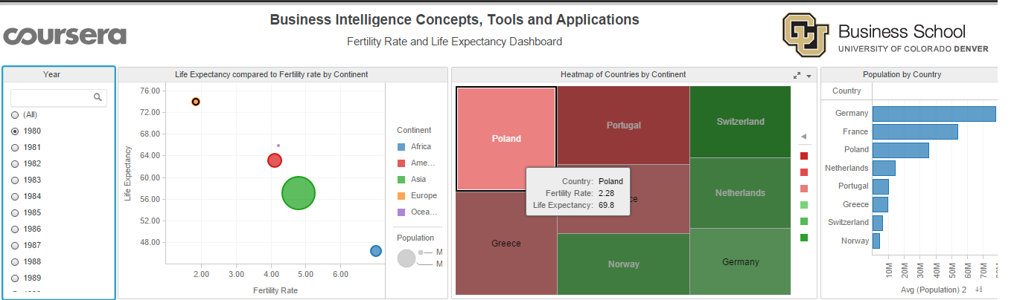

**In 2007: Poland has lowest fertility rate:**

